# Level Design

(Yueyang - Due to this being a midterm assignment I’ll be limiting the scope of this level design document to a single map/ mission for the Abyssal Legacy DLC)

Mission: Defense of Tartarus VII  
During the first wave of Protoss attack on the EkIII system. Deskorra is surrounded by Protoss units from all sides. Player have to destroy all 8 energy crystals scattered around the map to win.

Map: Nestling hill

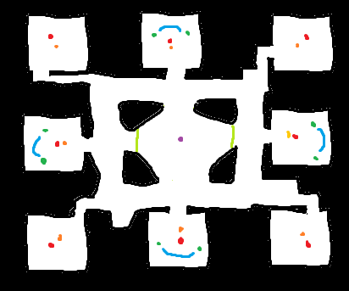

Purple: Deskorra(player) base

Green: bushes

Blue: crystal

Dark green: vespene gas

Red: Protoss base

Orange: Protoss energy field crystal (objective, destroying it will disable the Protoss base it’s in)

Black: acid lake

This is a king of the hill map. the player spawns in the middle and is attacked from all side.

The player is given 2000 crystal, 2000 gas, 200 population , a base, 2 overlord, all 3 hero units at the beginning of the game

For the first time ever, the player is given a base but no nearby mining resources.

Only the up, down, left, right Protoss bases will send out units to harass the player in the first 15 min. and only those bases have resources to mine.

The corner Protoss bases doesn’t attack until 15 minutes, but they have superior army/ defense structures.

Enemy warp-ins will start when only one energy crystal is left.

In the mission, the player has to multitask and micro manage all 3 hero units to attack and defend at the same time to succeed. Unlike other heroes in the game who are all essentially one man armies, the three heroes (see character design document) each have a unique role to play in army.

The Elokia’s web walls and bushes should create a more of a red alert style of defense rather than the traditional StarCraft type of defense.

Dostra is a squishy assassin. Dostra can wreak havoc in an enemy defense line but can also die in the blink of an eye.

Neshanic is an objective focused hero. Nashanir can lay down creep tumors that deals area damage, creating a no-man's zone and take down buildings really fast with the earthquake skill.

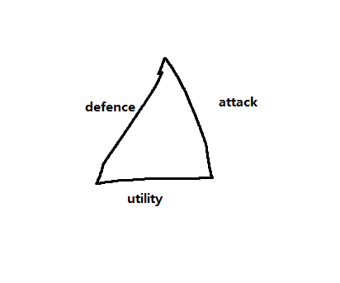  
A skilled player can rush down this mission by sneaking into enemy bases and destroying objectives before the enemy can react.  
Dostra for clearing a path into the enemy base

Nashanir for taking down objective

Elokia and other ranged units defend the base

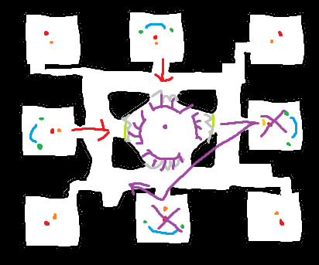

Or the player can go for a late game build. After taking down the first base, relocate Deskorra(base) there to gather resources then repeat when the mines are empty. Since the Elokia web walls only cost energy and the defenders are mobile unit, the player can build defensive and still move around. Having the base in a corner spot also means it’ll be easier to defend. But by taking the time to fully clear a base and relocating they are also delaying to 15 min and risking having all the enemy bases attack the player at once.

